root@cyberster:~$
DAY 05 — 06 / AGENT DEPLOYMENT & FIRST DETECTION
Wazuh SOC Lab · Cyberster Internship, Phase One

// 01 OBJECTIVE
With the Wazuh Manager running on the Ubuntu Server VM, today's focus shifted from building the SIEM itself to extending visibility outward: deploying Wazuh agents on the remaining lab endpoints, understanding the agent configuration file, and proving the full detection pipeline works end-to-end with a real test alert.
- Deploy and activate a Wazuh agent on the Kali Linux VM
- Deploy and activate a Wazuh agent on a Windows endpoint
- Read and understand the server, syscheck, and localfile blocks in ossec.conf
- Generate a failed-SSH-login test and confirm the alert reaches the dashboard
// 02 AGENT DEPLOYMENT — KALI LINUX
$ Deployment Wizard
Used the built-in deployment wizard under Server Management → Endpoints Summary → Deploy New Agent, rather than hand-writing the install command. Selected Linux → DEB → amd64 for Kali (Debian-based), and entered the Wazuh Manager's static host-only IP assigned on Day 3.
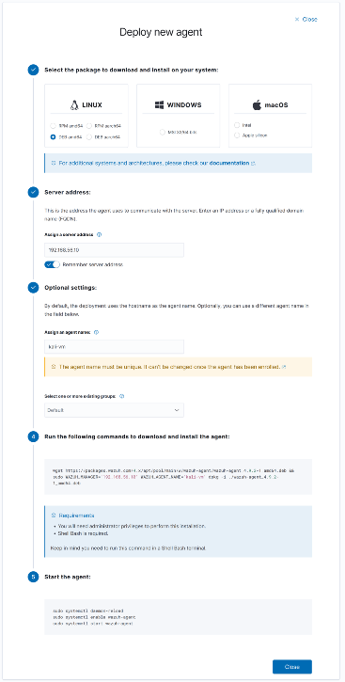

$ Manager IP Verification
Before running the generated command, double-checked the manager IP against the actual VM. The wizard auto-filled 192.168.56.10 as the Manager IP — confirmed this matches the Ubuntu Server's host-only adapter IP via ip a on the manager itself before proceeding, to avoid an agent that installs cleanly but never registers.
$ Install Command (Kali)
wget https://packages.wazuh.com/4.x/apt/pool/main/w/wazuh-agent/wazuh-agent_4.9.2-1_amd64.deb
sudo WAZUH_MANAGER='192.168.56.10' WAZUH_AGENT_NAME='kali-vm' dpkg -i ./wazuh-agent_4.9.2-1_amd64.deb
$ Starting the Agent Service
sudo systemctl daemon-reload
sudo systemctl enable wazuh-agent
sudo systemctl start wazuh-agent
sudo systemctl status wazuh-agent
Confirmed status as active (running). The agent appeared in the Endpoints Summary as kali-vm shortly after.
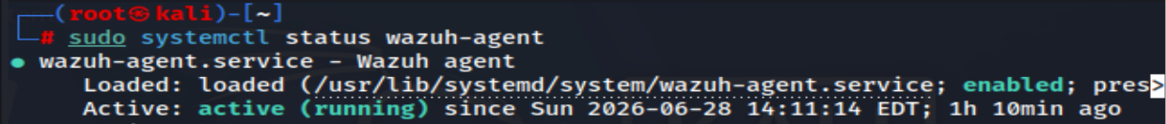
// 03 AGENT DEPLOYMENT — WINDOWS ENDPOINT
Originally planned as a separate Windows 10 VM, the second endpoint in this lab is instead the physical Windows 11 host machine running VirtualBox itself. This was the topology decided back on Day 2 (host machine as an additional Wazuh agent endpoint alongside the two VMs), so the deployment below targets the host directly rather than a guest VM.
$ Deployment Wizard — Windows
Selected Windows as the target OS in the same deployment wizard, entered the manager IP (192.168.56.10), and named the agent win10-vm during enrollment.
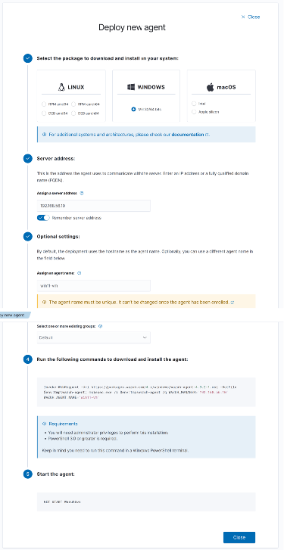

$ Install Command (Windows, elevated PowerShell)
Invoke-WebRequest -Uri https://packages.wazuh.com/4.x/windows/wazuh-agent-4.9.2-1.msi -OutFile $env:tmp\wazuh-agent.msi;
msiexec.exe /i $env:tmp\wazuh-agent.msi /q WAZUH_MANAGER='192.168.56.10' WAZUH_AGENT_NAME='win10-vm'
$ Starting the Service
NET START WazuhSvc
Verified via services.msc that the Wazuh service shows Running, in addition to the NET START confirmation message.
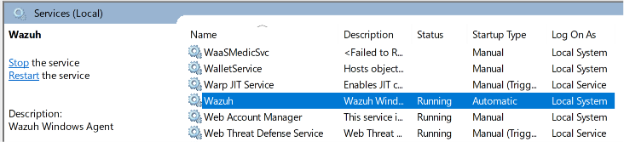
// 04 BOTH AGENTS — ACTIVE STATUS
Endpoints Summary page showing both registered agents simultaneously online, confirming the full enrollment-to-active pipeline succeeded for both endpoints within the expected 1–2 minute registration window.
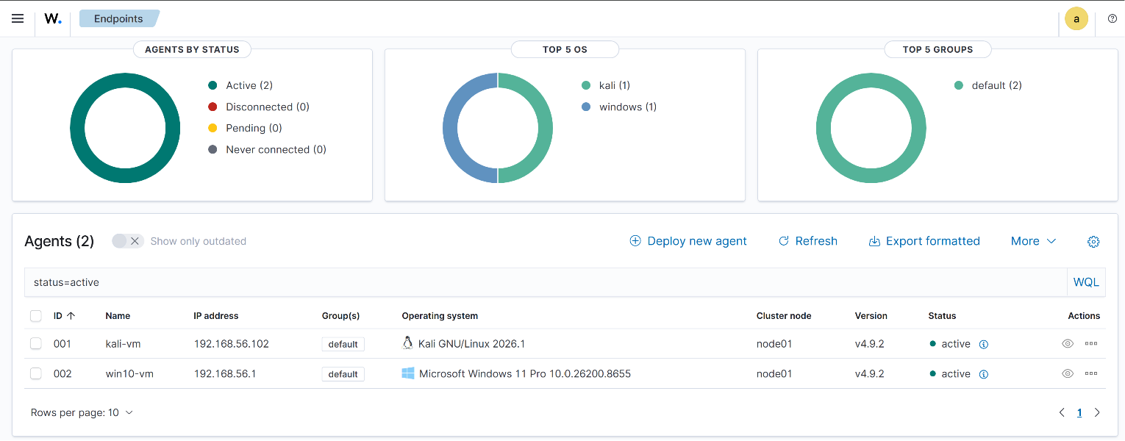
Endpoints Summary — kali-vm and win10-vm both reporting Active (v4.9.2, node01)

Field | Value
kali-vm | 192.168.56.102 — Kali GNU/Linux 2026.1 — Active
win10-vm | 192.168.56.1 — Microsoft Windows 11 Pro (host machine) — Active
Manager | 192.168.56.10 — node01 — v4.9.2
// 05 OSSEC.CONF WALKTHROUGH
Opened the agent configuration file to identify the three sections that matter most for next week's work: where data is sent, what file-integrity monitoring covers, and which logs are actually being read from the host.
$ Server Block
Defines where the agent ships its data. Points to the manager's IP, the listening port (1514, the standard Wazuh agent-manager port), and the transport protocol.
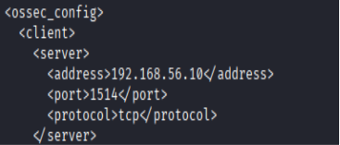
<server> block — address 192.168.56.10, port 1514, protocol tcp

$ Syscheck Block (File Integrity Monitoring)
Controls FIM. Enabled by default, runs a full scan immediately on startup and then every 12 hours (43200 seconds) afterward, watching core system directories for unauthorized changes — a key signal for detecting tampering or malware persistence.
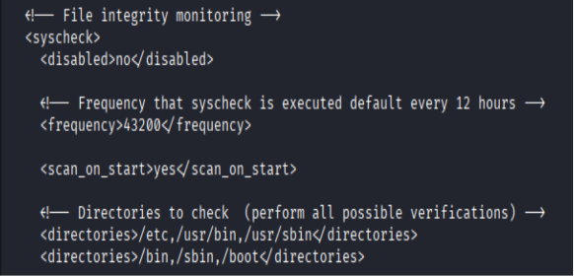
<syscheck> block — scan_on_start enabled, 12-hour frequency, /etc /usr/bin /bin /sbin /boot watched

$ Localfile Blocks (Log Sources)
Each localfile block names one specific log source the agent reads. Defaults on Kali included active-responses.log (Wazuh's own response actions) and dpkg.log (package install/removal history) — useful, but neither one captures authentication events.
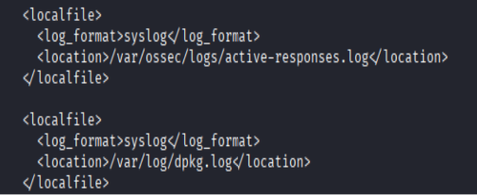
Default <localfile> blocks — active-responses.log and dpkg.log
$ Gap Found: auth.log Not Monitored by Default
Since the SSH brute-force test (Section 06) targets the Ubuntu Server manager, checked its ossec.conf rather than Kali's — Kali is the attacker in that test, not the target, so its config was never going to contain auth.log. A grep for auth.log on the manager's own ossec.conf returned nothing, meaning the manager's local agent (agent 000) was not yet watching its own SSH log. Added the block manually:
<localfile>
<log_format>syslog</log_format>
<location>/var/log/auth.log</location>
</localfile>
Restarted the manager service to apply the change before running the test:
sudo systemctl restart wazuh-manager
sudo systemctl status wazuh-manager

// 06 SSH BRUTE-FORCE TEST & ALERT VERIFICATION
With auth.log now monitored, ran a controlled failed-login test from Kali against the Ubuntu Server manager to confirm the full pipeline — endpoint log → agent → manager → dashboard — actually works.
$ Test Command (run from Kali)
for i in {1..8}; do ssh hanzallah@192.168.56.10; done
Entered a deliberately incorrect password on each prompt. Verified the attempts landed in auth.log on the manager via sudo tail -20 /var/log/auth.log before checking the dashboard.

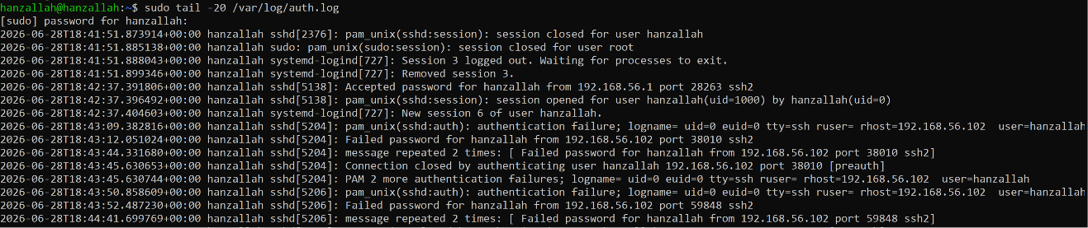
$ Alerts in the Dashboard
Filtered Security Events by manager.name and rule.level (7–11) over the last 24 hours. The brute-force attempt was caught and correctly classified.
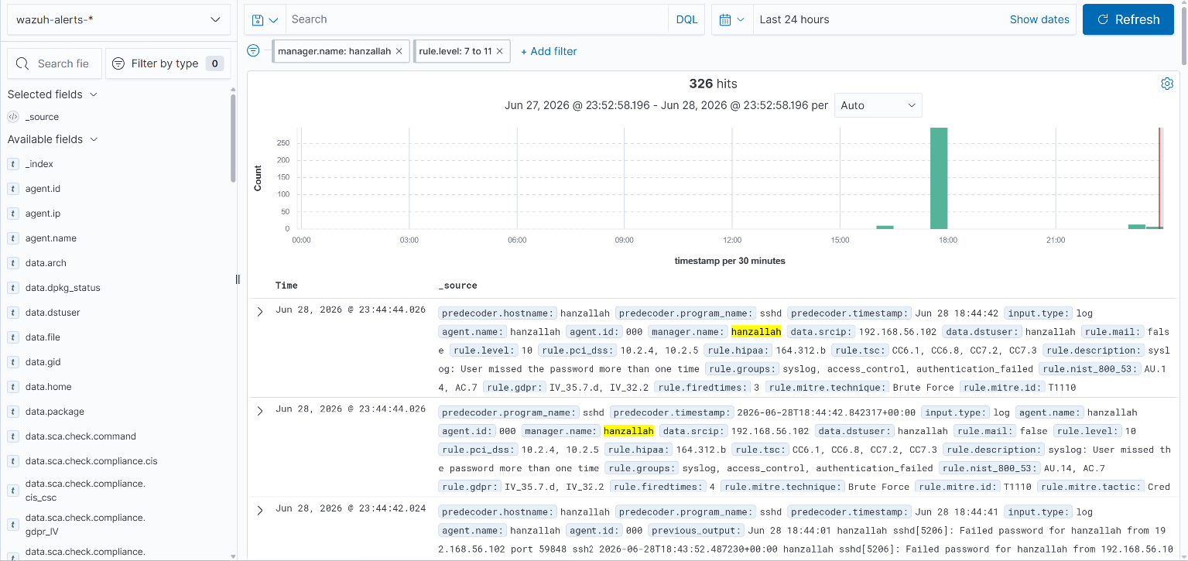
Security Events — 326 hits, rule level 10, “User missed the password more than one time,” MITRE T1110 (Brute Force)

Field | Value
rule.description | User missed the password more than one time
rule.level | 10
rule.mitre.technique | Brute Force (T1110)
data.srcip | 192.168.56.102 (Kali)
agent.id / name | 000 / hanzallah (manager's local agent)
rule.firetimes | Incrementing per repeated attempt (3, 4, ...)
326 total hits is expected, not a bug — Wazuh's decoder pipeline correlates multiple sub-events (PAM, sshd, syslog parsing layers) per single failed login, so one SSH attempt typically fires several related log lines.

// 07 TROUBLESHOOTING NOTES
- Topology correction: the second endpoint is the physical Windows 11 host, not a separate Windows 10 VM — documented accurately rather than implying a VM exists.
- IP sanity check: verified the wizard-generated manager IP (192.168.56.10) against ip a on the manager before deploying agents, to avoid a silent enrollment failure from a typo'd address.
- Missing localfile block: the manager's default ossec.conf did not monitor auth.log out of the box; added the block manually and restarted wazuh-manager before testing.

